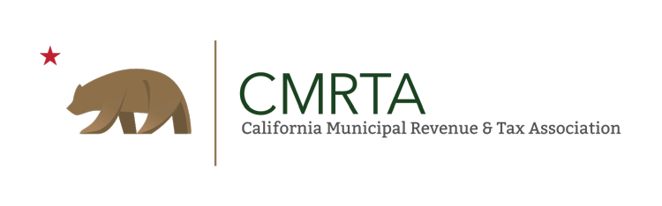

California Municipal Revenue and Tax Association

Lighthouse Award for Excellence
The Lighthouse Award was established in 2003 by CMRTA to recognize outstanding achievements by staff of CMRTA member cities*. Candidates for the award have made unique contributions to their organizations that benefit businesses, community, CMRTA members, or their City as a whole. The contributions have resulted in lower costs, increased revenue, or more effective delivery of services to their customers.

The purpose of the CMRTA Lighthouse Award for Excellence program is to recognize and promote the outstanding efforts and innovative solutions by a Local Government Revenue Professional in areas of:

- A significant increase in revenues for the City as a result of a special project, amnesty, audit, or effort made by that organization.

- New technological enhancement that made the City more efficient and resulted in cost savings.

- Developing or creating an ordinance, regulation or making legislative changes that is unique in its approach or design and that made a significant impact on the City and the Community.

The contribution must be recognized as a benefit to the Association as a whole or in part. It should be a new concept that can be used as a learning tool for other CMRTA members.

* “Cities” includes all cities, city/counties, and State or Federal agencies.

Eligibility and Instructions

All CMRTA member cities* who provide a program or service that has given tangible and measurable results are eligible to apply for an award.

Instructions must be followed carefully as this will facilitate a fair evaluation of all applications and ensure objectivity among entries.

Application:

- Complete the attached application and attach it to the narrative. The City Manager or Department Head must approve and sign the application.
- The typed narrative must not exceed five (5) 8.5” x 11” pages with one-inch margins in no smaller than 12-point type size.

Please respond to the following:
  - One page or less: The Challenge – Describe the challenge, need or concern that prompted the development of the program.
  - Two pages or less: The Solution – Describe the steps taken by the City to address the problem / challenge. Explain how the program’s objectives were met. If there is a partnership with other agencies, please highlight the relationship of the partnership in the solutions.
  - Two pages or less: The Results – Describe the results of the program. How did the program affect the community or improve service delivery? What, if any, was the cost or resource savings? What affect, if any, did the program have on enhancing the city’s fiscal stability and public’s confidence in the city and its officials?

- A City may submit more than one application per year. However, only one award will be given per City.
- A program or activity may only be submitted for one category. A City may submit other, separate applications for other categories.
- The completed application must be submitted electronically to the State 1st Vice President in a PDF Format.
6. There may be multiple award recipients in each category or there may be no recipients in a category each year.

* “Cities” includes all cities, city/counties, and State or Federal agencies.

Eligibility and Instructions (Continued)

Scoring Criteria:

The selection juries will judge each entry on:
- How well the problem/challenge is outlined
- The innovativeness of the solution
- The quality of the results achieved

In addition to considering each application in light of the qualities set forth for each category description, the following criteria will be used in the evaluation and scoring process. Be sure to address these criteria in your application. (Some criteria may not apply to a particular category; therefore, in that case, no penalty will apply.)

Community Engagement
To what extent is the public informed, involved, and has input that is fully considered?
Saving and Efficiencies/Improved Services
To what extent does the program or service result in greater public benefits and / or lower costs?
Positive Citizen Feedback
To what extent is the public reaction to the program or service supportive and positive?
Measurable and Transferable Results
To what extent are the results and benefits of the program or service verifiable, measurable, and useful to other cities?
Partnerships
To what extent are other agencies, cities, counties, State or Federal Agencies, and businesses involved, both formally and informally?
Application of Technology
To what extent are technologies involved in innovative ways in the program or service?

Business Development
To what extent does the program prepare businesses to be informed, engaged, and responsible?

Strategic Priorities – To what extent does the program, policy, or activity advance the CMRTA’s goals and objectives?

2022 CMRTA Lighthouse Award for Excellence Application

City / Agency Information

Name of City / Agency: Current Population for 2022: City General Fund Budget $

Category of Entry (Please check only one)

- Increase in revenues
- New technological enhancement
- Developing new ordinances or regulatory change
- Legislative change
Program Information
Name of Program: Date Program was implemented:
Contact Person (Person Preparing Application):

Name: Title:

Address:

City: Zip:

Telephone: Fax: Email:
Brief description of the program: (This description must explain the program. It will be used in all summaries of your program. Maximum 100 words.)

2022 CMRTA Lighthouse Award for Excellence Application (Continued) If chosen, would you like to be contacted prior to the annual Conference Award Ceremony? Yes No. If yes, please complete: the following:
Contact Person:

Name: Title:

Address:

City: Zip:

Telephone: Fax:

Email:

The City Manager or Department Head must sign this application before it is submitted.
City Manager / Department Head

Name: Signature:

Phone: Fax: Email:

Submit electronically to:

CMRTA 1st Vice President Attn: Cris Gaiennie
cgaiennie@carson.ca.us

For any questions regarding this, please contact 1st V.P. Cris Gaiennie. DEADLINE: Friday, September 30, 2022, by 5:00 p.m.

